

**KING FAHAD ISLAMIC PRIMARY SCHOOL- BUSEGA**

**END OF TERM III EXAMINATION 2024**

LITERACY 1B -P.1

Name: _______________________________________

Class: __________________________________________

**SECTION A**

1. Name this type of weather.

j0293828_______________________________________________

1. State any two activities done at school.

(i)______________________________ (ii)____________________________

1. How is this item useful in the classroom?

_______________________________________________________

1. Mention any one useful person found in a community.
2. Draw any two things found in your classroom.

|  |  |
| --- | --- |
|  |  |

1. How is a watering can useful to the farmers?

________________________________________________________________

1. Write the colour of your school uniform.

________________________________________________________________

1. Underline the types of seasons we have.

Wet season windy season dry season summer season

1. Name the commonest type of transport used by people.

________________________________________________________________

1. How do we call the things made locally using our hands? ________________________(crafts, materials)
2. A __________________is a person who rides a bicycle or motorcycle . (driver, cyclist)
3. Draw these things made from clay.

|  |  |  |  |
| --- | --- | --- | --- |
|  |  |  |  |
| pot | cups | flower vase | charcoal stove |

1. In which community do we find teachers?

________________________________________________________________

1. Match correctly

List A List B

Ship railway station

Bus stage

Train habour

Aeroplane bus park

Motorcycle airport

1. Ship __________________________________________________
2. Bus __________________________________________________
3. Train _________________________________________________
4. Aeroplane ___________________________________________
5. Motorcycle __________________________________________
6. Who heads a school?

_______________________________________________________________

1. Name the place where we ease ourselves from.

_______________________________________________________________

1. Name these buildings found at school.

|  |  |
| --- | --- |
| C:\Users\Esther\AppData\Local\Microsoft\Windows\Temporary Internet Files\Content.Word\scan0044.jpg |  |
|  |  |

1. How are children related to their parents?

________________________________________________________________

1. Draw this school symbol.

|  |
| --- |
|  |
|  |

**Section B (70marks – 2@)**

1. Study the road sign below and answer the questions
2. 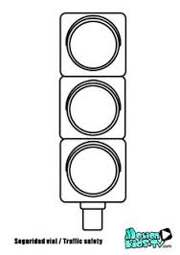Name the road sign shown

_____________________________________________________

1. Write the colours of the road sign shown in their order.

(i)________________________ (ii)______________________

(iii)________________________

1. (a) How do we call a group of people related by blood, marriage or adoption?

_____________________________________(family, community)

(b)Write the roles of the following people in a family.

(i) mother_______________________________________________________

(ii) children_____________________________________________________

(iii)father ______________________________________________________

1. (a) _________________________is the protecting of people and their property from danger. (security, peace)

(b)Write two people who promote peace and security at school.

Teachers Prefects Police

Matrons farmers

(i)_____________________________ (ii)____________________________

1. (a) Give any two animals which help in transport.

(i)____________________________ (ii)____________________________

(b) How is transport useful to people? (two ways)

For ______________________ carrying food

For______________________ carrying buildings

Carrying animals.

1. (a) Write two food you eat at school.

(i)___________________________ (ii)_______________________________

(b) Mention one reason why you eat food.

________________________________________________________________

(c)Identify the place where food is prepared from at school.

________________________________________________________________

1. The picture below shows an item we make. Study it and use it to answer the questions

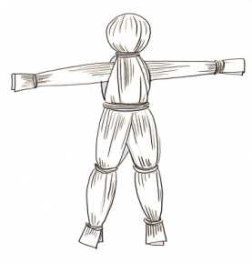

1. Name the picture.________________________________________
2. How useful is the picture to children?

______________________________________________________________

1. Write one material used to make the picture shown. _____________________________________________________
2. Write “yes” or “no”
3. A policeman enforces law and order________________
4. Children go to school to get knowledge _____________
5. Wind is moving air. _________________________________
6. A carpenter makes tooth brushes.___________________
7. Draw these things which give us light.

|  |  |  |  |
| --- | --- | --- | --- |
|  |  |  |  |
| sun | stars | candle | fire |

1. Circle the school needs

Stones , money buildings radios water